CS322 Formal Languages and Automata

20150645 임성민

Input/Output Example

해맑

1. 받침우선  
   g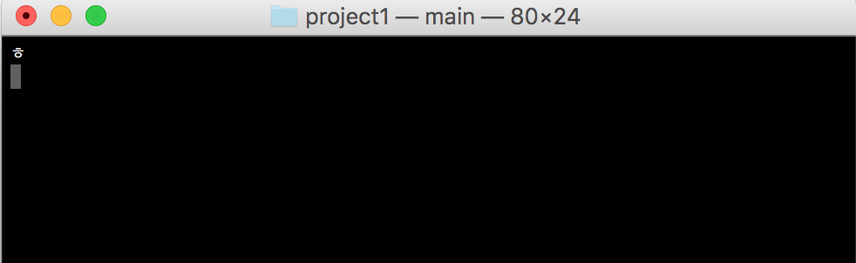  
   go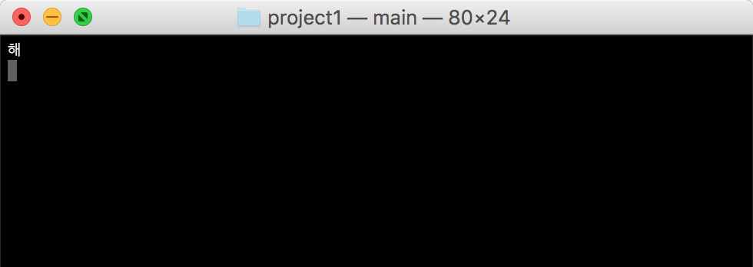  
   goa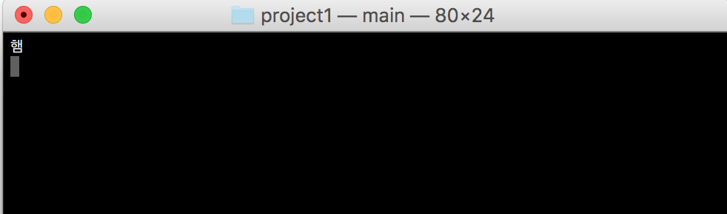

goak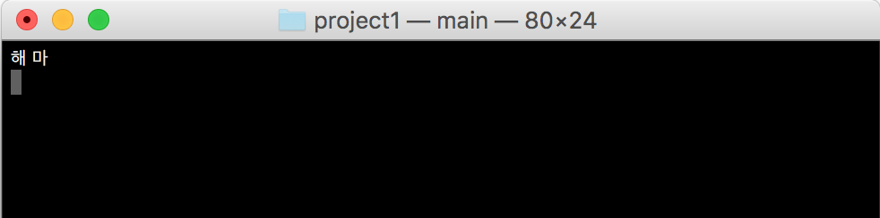

goakf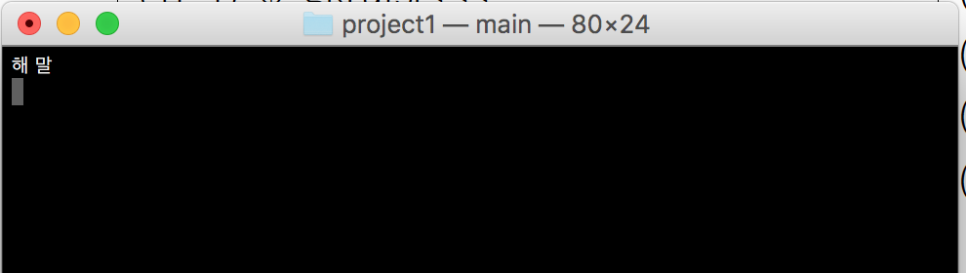

goakfr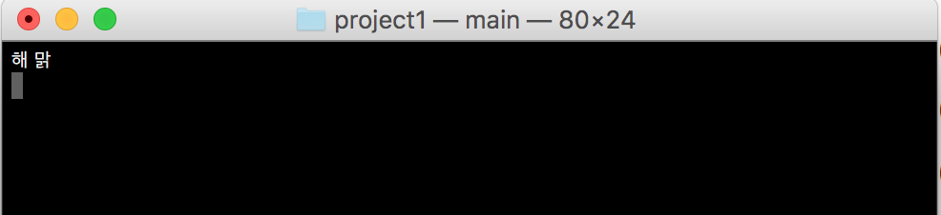

goakfr<



goakfr<<



goakfr<<<

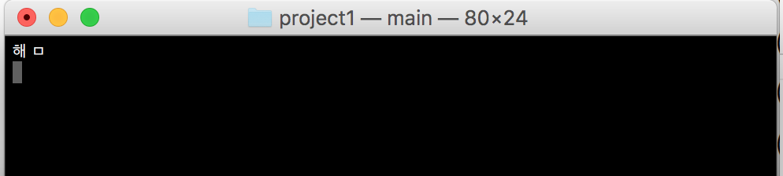

goakfrek<<<<



goakfr<<<<<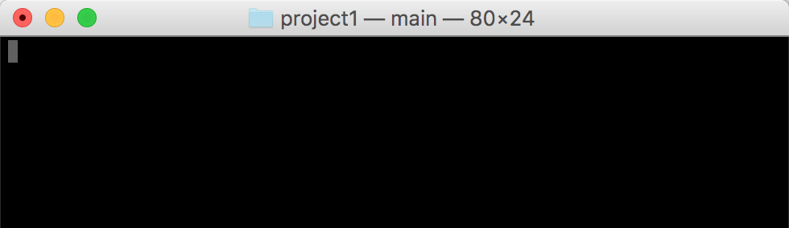

1. 초성우선  
   g

go

goa

goak

goakf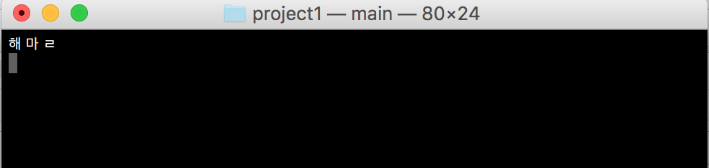

goakfr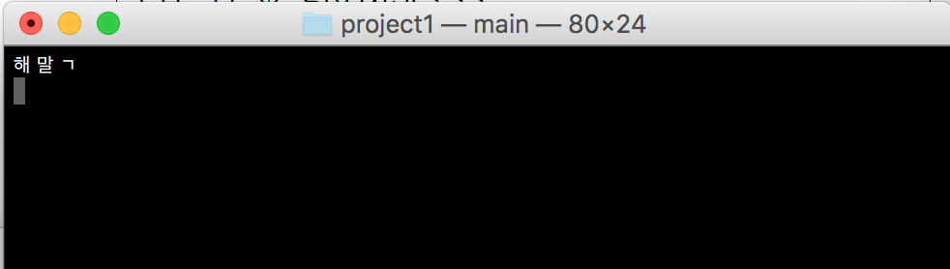

goakfr<



goakfr<<



goakfr<<<



goakfr<<<<



goakfr<<<<<

